Building a PiJack box

Start with a OEM version of the Labjack U3.
3D print one of our boxes. The .stl file for the box can be found on the tinkercad website here:
https://www.tinkercad.com/things/1ZXSIU43Vk7-pijack-case-for-labjack-u3-oem

+5v
2.2k
2.2k
To current sensor
FIOx
Cut 6 ft. lengths of the hookup wire,
FIOx
56k
2.2k
To test point
one piece of
Brown,
Red and
Orange
Two pieces of
Yellow
Green
Blue
Violet
White
and 3 lengths of the 3-wire gray cable for the current sensors. Strip back about 4” of the outer gray sheathing on the current sensor cables, so the wires will fit through the cable glands.

Solder a 56K precision resistor to the end of each colored piece of hookup wire.
For the 3 Current sensor cables, solder a 2.2K precision resistor to the end of the green wire.
Put heat-shrink tubing over the connections
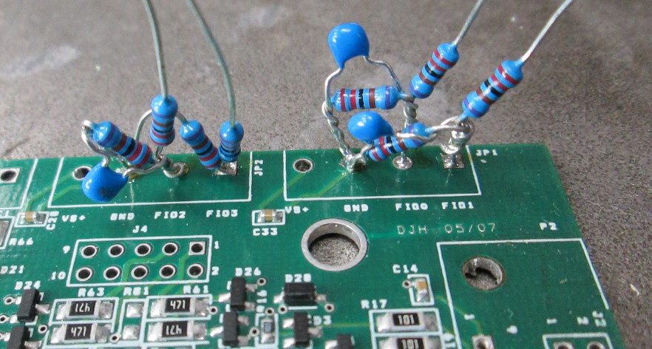
Three current sensors connect to the FIO0-FIO2 inputs on the circuit board.
Solder a 2.2k resistor in parallel with a 10uf capacitor for each current sensor (3x)Bend them to fit between the FIO input line and ground, but solder only the ground side.
Insert the 2.2k resistor attached to the cable into the corresponding FIO input line and now solder both resistors to that input. Solder the red wires to +5v and black to gnd.

Color code the far end of the current sensor cables with white heatshrink tubing colored with sharpie pens. (So the user can tell which is which.)
FIO0=Brown
FIO1=Red
FIO2=Orange

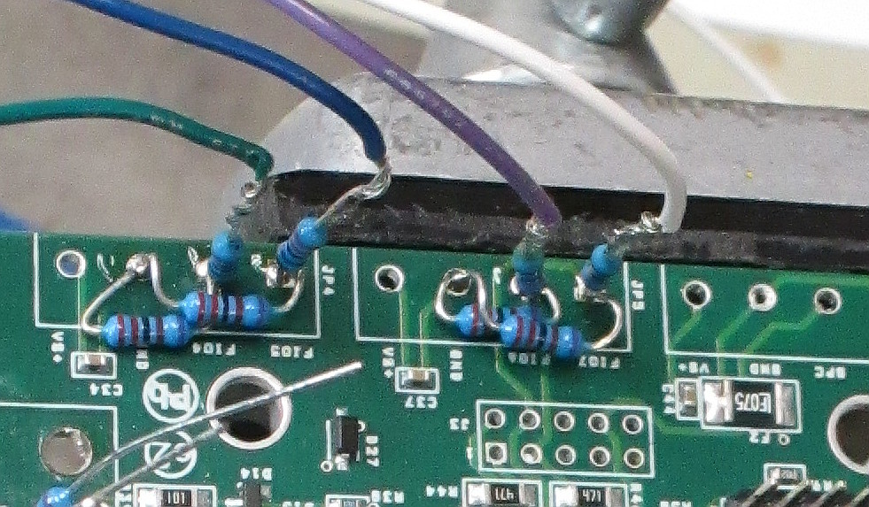
All the other FIO lines should have the 56K resistor soldered to the input, plus a 2.2k between the input and ground, like this photo.
Colors are:
FIO3 Yellow
FIO4 Green
FIO5 Blue
FIO6 Violet
FIO7 White

Stand 8 of the 2.2k precision resistors in the DB15 connector holes 4,5,6,7 and 12,13, 14 & 15. Solder them in place. Connect the leads which are sticking up all together to hole 8, which is gnd.
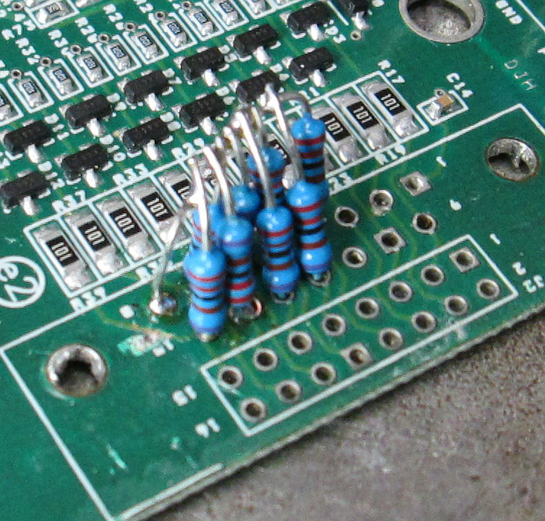
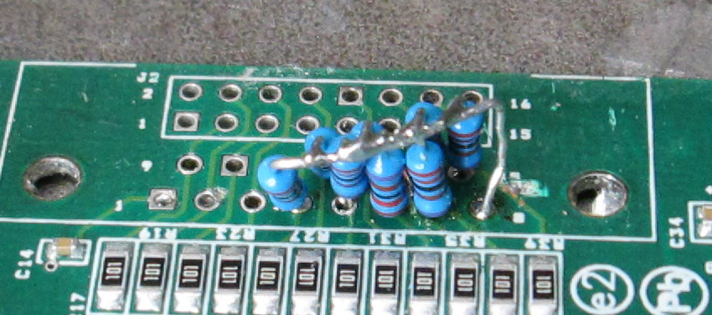

Connect the colored hookup wires with 56K resistors on the end to J2:
Hole Color
8 Brown
9 Red
10 Orange
11 Yellow
12 Green
13 Blue
14 Violet
15 White

Solder a 6ft Black hookup wire to one of the GND connections on the U3 board. This will be the ground connection for all the voltage measurements. Run the ground and the wires from J2 out through the gland labeled “E”
Run the other wires including the current sensor cables out through the gland labeled “F”

Trim the USB cable down to about 10”, by removing the “B” connector. Run the wire through the hole in the side of the case and solder to the U3 as shown. Put a cable tie around the USB wire inside the box to act as a strain relief. Close up the box.
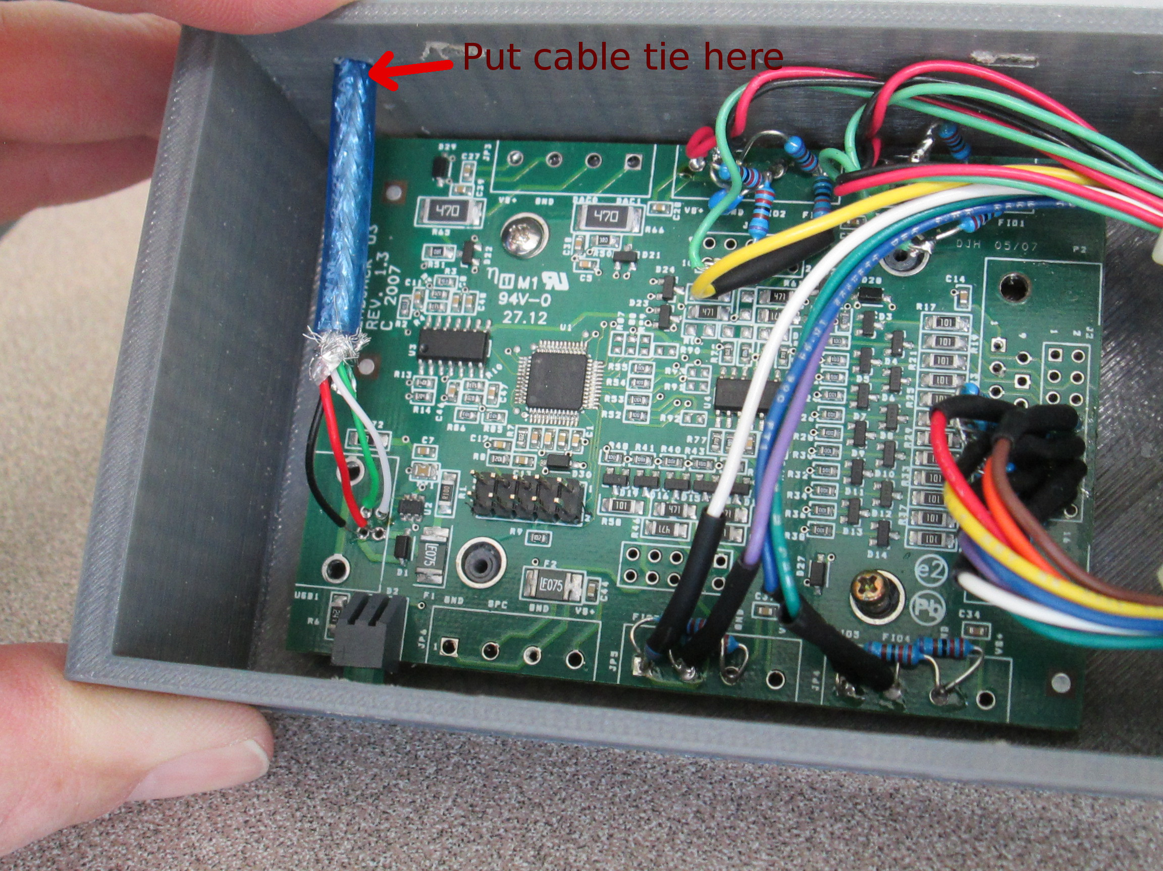

Before crimping on the connectors, verify there is colored heat-shrink tubing over the end of the 3 current sensor cables to identify them.
Brown on FIO0
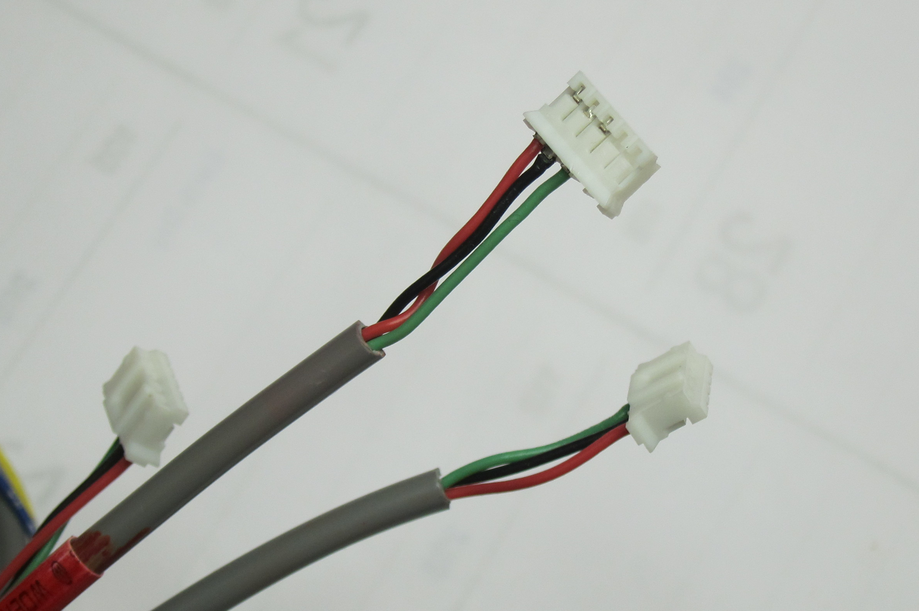
Red on FIO1
Orange on FIO2

Attach crimp ends on the cables for the hall effect current sensors.
Pin 1 Red
Pin 2 Black
Pin 3 Green
4 & 5 Not used

Part links: connector shells for current sensors
crimp pins for above connector shells
Hall effect current sensors

